Free Crochet Pattern: Newborn Baby Hat
By Rachel Choi – 114 Comments
Here is another hat/beanie that is great to make and donate to charities, hospitals or someone in need. It is designed to fit an average newborn head, and although baby heads may vary in size, there is extra length at the bottom of this hat to fold up and should stretch depending on the yarn you use. Feel free to change colors and get creative with this basic hat! | 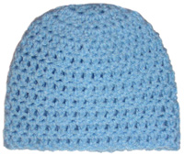

Skill Level:
Finished Size: 5 1/2″ (14 cm) tall, 6″ (15 cm) wide when flat
Note: hat is meant to stretch
Materials:
Medium Weight Yarn (small amount)
Crochet Hook I (5.50 mm)
Gauge: Rounds 1 – 3 in pattern creates a circle that is 3 3/4″ in diameter
Crochet Pattern: Newborn Baby Hat
Round 1: ch 4, 12 dc in forth ch from hook, sl st in top of beg ch: 12 dc
Round 2: ch 3, 2 dc in each dc around, sl st in top of beg ch-3: 24 dc
Round 3: ch 3, (2 dc in next dc, dc in next dc) around, sl st in top of beg ch-3: 36 dc
Round 4 – 10: ch 3, dc in each dc around, sl st in top of beg ch-3: 36 dc
Finish off.
You may also like to check out the Crochet Pattern: Family Beanie Set – 6 sizes. This pattern set has various beanies for you to crochet!  Be sure to check out the Crochet Spot Store for more hat and baby patterns! | 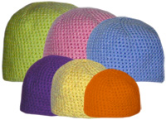

https://www.crochetspot.com/free-crochet-pattern-newborn-baby-hat/

